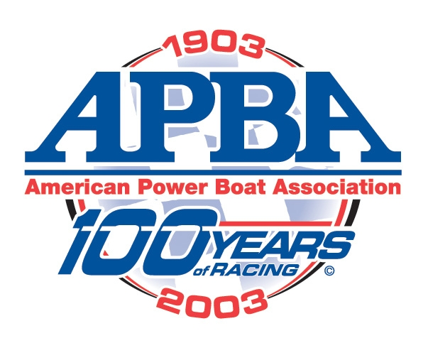

OUTBOARD PERFORMANCE CRAFT

Championship Request Form

Check one: Regional_____ Divisional_____ National_____ North American_____ World_____

Date(s) of race_____________________________ Region___________

Location __________________________________ Conducting Club_______________________

Class(s) __________________________________________________________________________

Prizes ____________________________________________________________________________

Have all Region Chairman been notified in writing? __________ Date_________
Attach copies of letters

Have all other approvals been secured? ___________________ Date_________

The appropriate deposit as stated in the OPC Rule 14 Championships, must sent to OPC Chairman for approvals.
Checks to be made out to APBA

Note: All Region races must be approved by the Region Chairman. All Divisional races are approved by the OPC Chairman, all Region Chairman in the Divisional area must be notified. All races must be approved by the Region Chairman. All Championship events, the OPC Chairman and the Region Chairman must be notified 60 days prior to the event. In case of a cancellation of an event, the club who held the bid for that event will forfeit any deposit money. They will however be allowed to reschedule the event without further bidding if there is no reduction of prizes and classes. Any Championship not bid and approved at the National Meeting shall be awarded on a first come basis upon request to the OPC Chairman. The OPC Commission will be notified.

Person applying for race ____________________________________________

Telephone Number……. ____________________________________________

Email……………………. ____________________________________________

